**Terraform script to create highly available infrastructure in AWS. The infra should have1 vpc, 3 subnets setup in 3 different az and 2 instances setup in 2 different subnets**

**Steps:**

Creating a script .tf file and named as main.tf

**Scripts to create two EC2 instances in eu-west-1 :**

provider "aws" {

region = "eu-west-1"

}

resource "aws_vpc" "tf_vpc" {

cidr_block = "10.0.0.0/16"

tags = {

Name = "My-first-vpc"

}

}

resource "aws_internet_gateway" "tf_igw" {

vpc_id = aws_vpc.tf_vpc.id

tags = {

Name = "My-first-igw"

}

}

resource "aws_route_table" "tf_rt" {

vpc_id = aws_vpc.tf_vpc.id

route {

cidr_block = "0.0.0.0/0"

gateway_id = aws_internet_gateway.tf_igw.id

}

tags = {

Name = "My-first-rt"

}

}

resource "aws_route_table" "tf_rt1" {

vpc_id = aws_vpc.tf_vpc.id

route {

cidr_block = "0.0.0.0/0"

gateway_id = aws_internet_gateway.tf_igw.id

}

tags = {

Name = "My-first-rt"

}

}

resource "aws_route_table_association" "tf_subnet_assosiation1" {

subnet_id = aws_subnet.tf_subnet1.id

route_table_id = aws_route_table.tf_rt.id

}

resource "aws_route_table_association" "tf_subnet_assosiation2" {

subnet_id = aws_subnet.tf_subnet2.id

route_table_id = aws_route_table.tf_rt.id

}

resource "aws_subnet" "tf_subnet1" {

vpc_id = aws_vpc.tf_vpc.id

cidr_block = "10.0.1.0/24"

availability_zone = "eu-west-1a"

}

resource "aws_subnet" "tf_subnet2" {

vpc_id = aws_vpc.tf_vpc.id

cidr_block = "10.0.30.0/24"

availability_zone = "eu-west-1b"

}

resource "aws_subnet" "tf_subnet3" {

vpc_id = aws_vpc.tf_vpc.id

cidr_block = "10.0.70.0/24"

availability_zone = "eu-west-1c"

}

resource "aws_security_group" "tf_sg" {

vpc_id = aws_vpc.tf_vpc.id

name = "terraform-sg1"

description = "SG used for SSH"

# Inbound rule for ssh (port 22)

ingress {

from_port = 22

to_port = 22

protocol = "tcp"

cidr_blocks = ["0.0.0.0/0"]

}

# Inbound rule for HTTP (port 80)

ingress {

from_port = 80

to_port = 80

protocol = "tcp"

cidr_blocks = ["0.0.0.0/0"]

}

}

resource "aws_instance" "terraform-instance1" {

ami = "ami-07355fe79b493752d"

instance_type = "t2.micro"

subnet_id = aws_subnet.tf_subnet1.id

vpc_security_group_ids = ["sg-09eedc87ceb7361c2"]

tags = {

Name = "My-first-tf-instance"

}

}

resource "aws_instance" "terraform-instance2" {

ami = "ami-07355fe79b493752d"

instance_type = "t2.micro"

subnet_id = aws_subnet.tf_subnet2.id

vpc_security_group_ids = ["sg-09eedc87ceb7361c2"]

tags = {

Name = "My-Second-tf-instance"

}

}

Commands:

Terraform init

Terraform validate

Terraform plan

Terraform apply

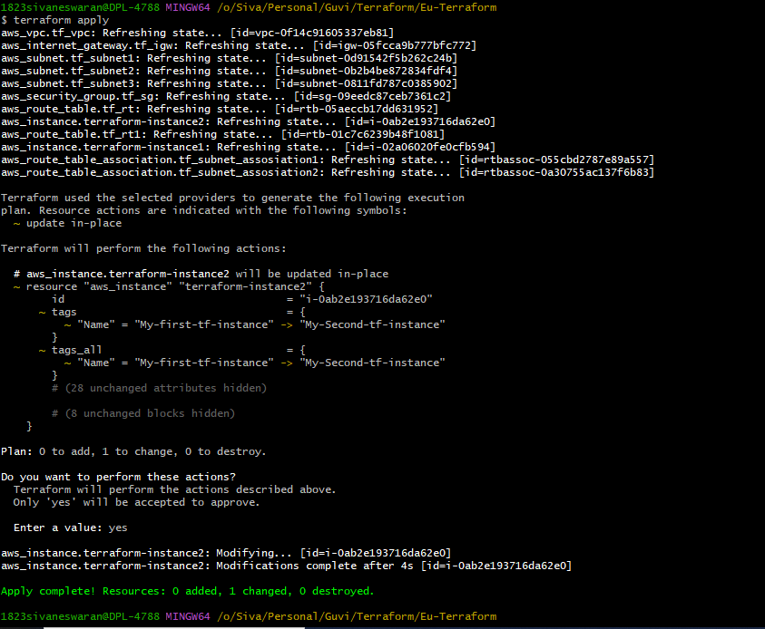

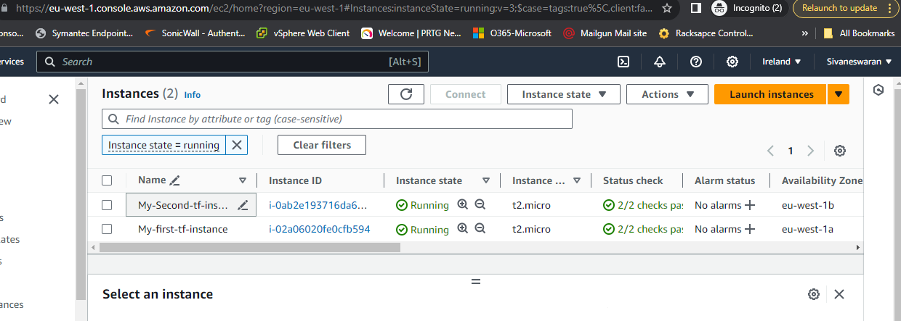

First EC2: subnet status

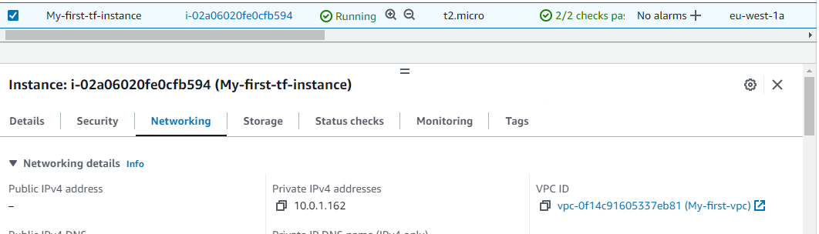

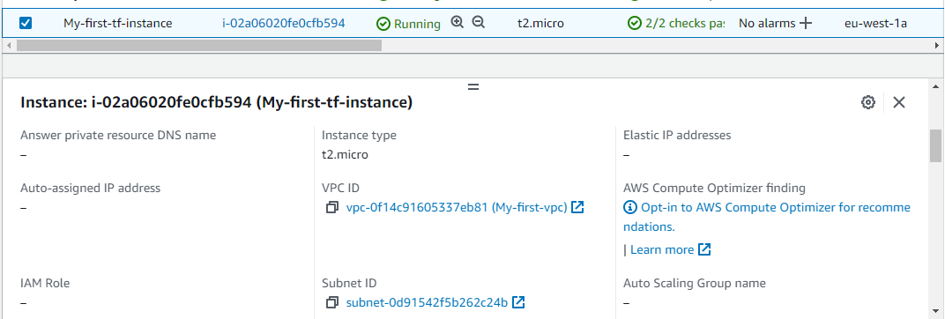

Second EC2: subnet status

